**Steps to create a Java Class in Eclipse IDE**

**Step 1 : Open eclipse**

**Step 2 : Create a new project**

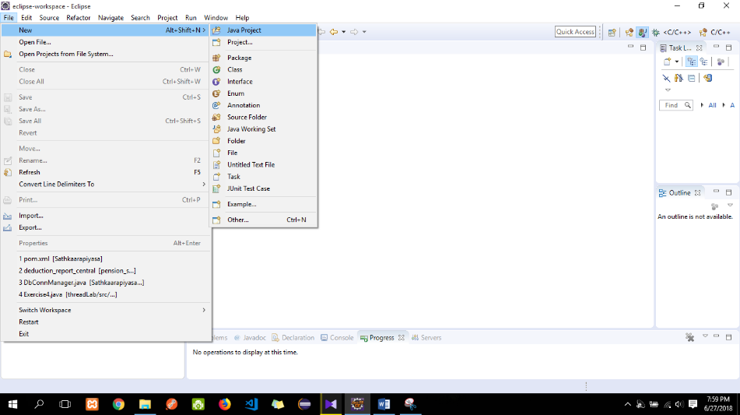 File New Java project

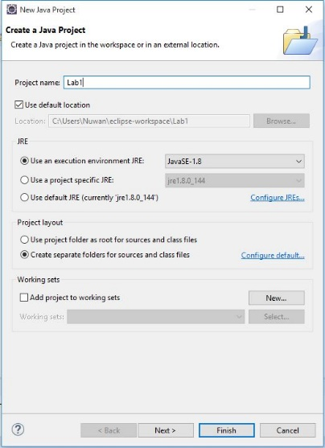

**Step 3: Create a new Package**

Right click on src New Package

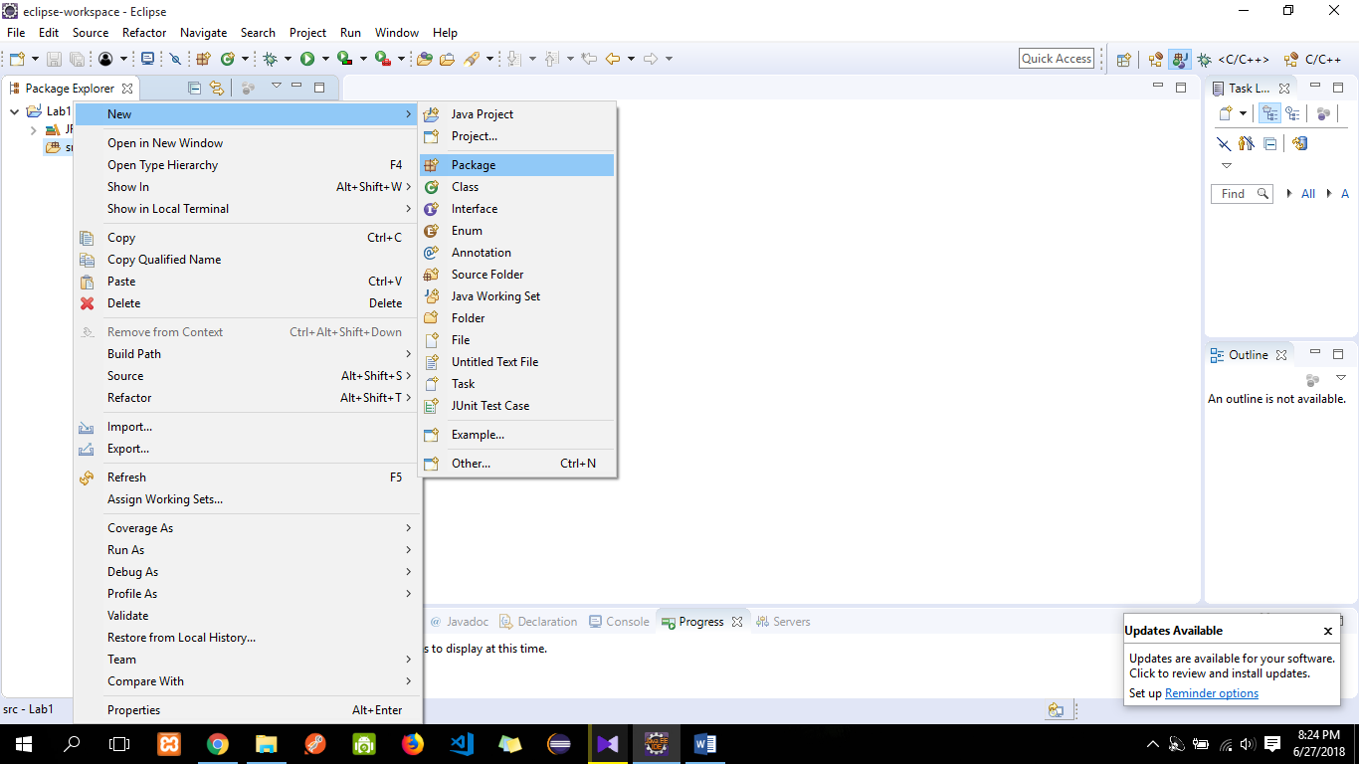

**Step 4: Create a java class within the created package**

Right click on created Pacakage New Class

**Question**

1. Implement Stack class to store characters. Identify the data members required and implement the below methods with the constructor.

Push(), Pop(), Peek(), isEmpty() and isFull()

1. Develop an application to
2. Insert characters to the stack using push() method.
3. Remove the content of the stack and display them.
4. Comment on the order of insertion to the stack and the order of removal from the stack.
5. Use the stack class created above and check whether a user entered expression is correctly parenthesized.

Ex: 3 + (( 6 * 2) – 3) 🡪 valid

5 * 6 + (2 - 5 🡪 not valid